Sanya sababbin BAKAKEN Hausa cikin na’urar ku (Computer)

1. Jeka Start ka danna kamar haka

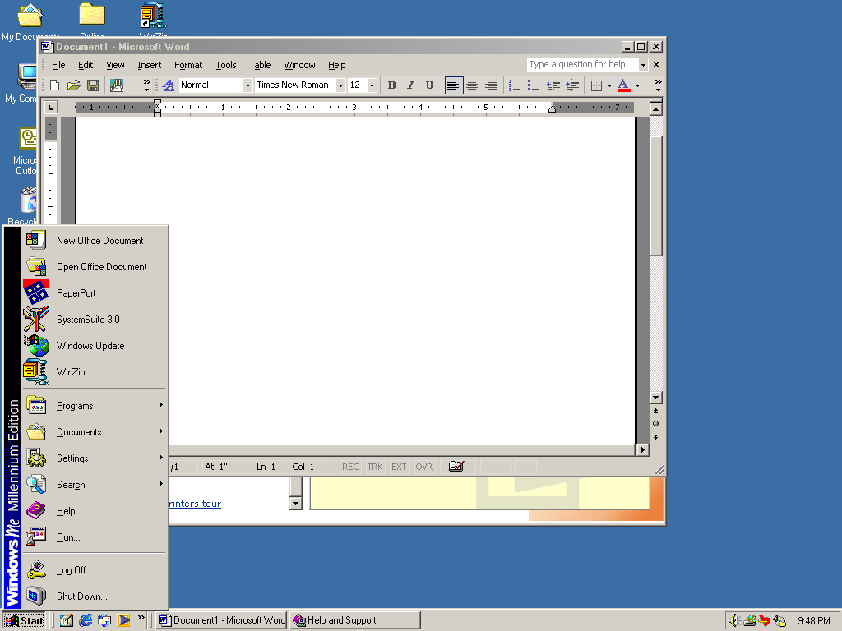

2. Jeka Setting ka danna, daga nan ka tafi Contol Panel kamar yadda hoton dake kasa ya nuna

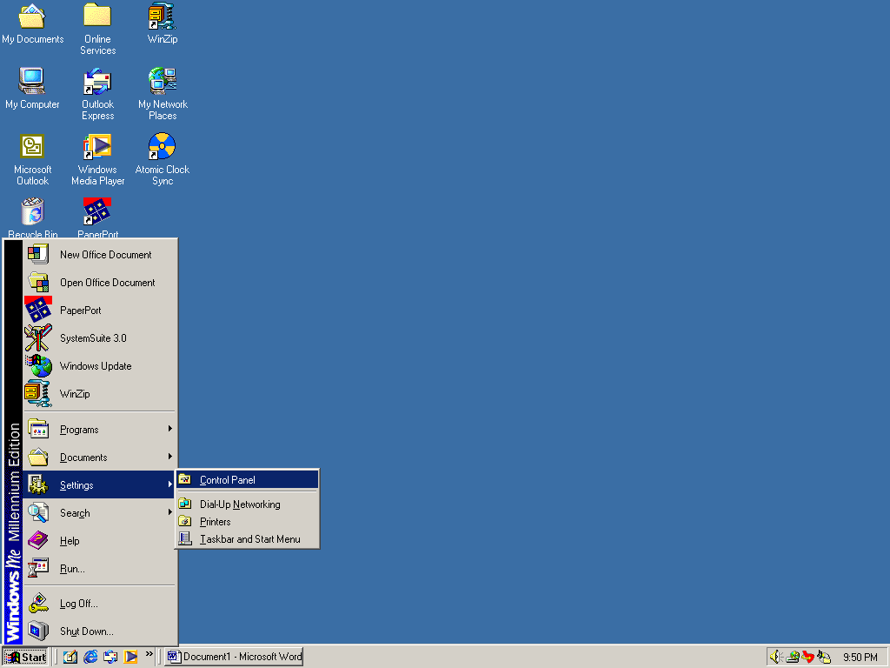

3. Idan baku ga komai ba ku bude View all Contol Panel options gaba daya

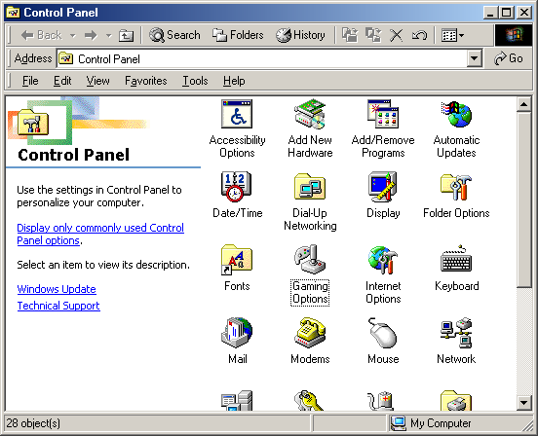

4. A cikin Contro Panel, sai a zabi Kundin (Folder) Fonts ka danna

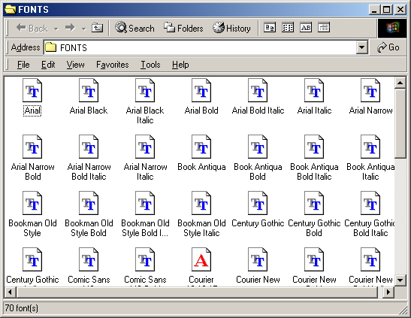

5. Daga nan sai ka bude File, zabi Install New Fonts ka danna kamar haka:

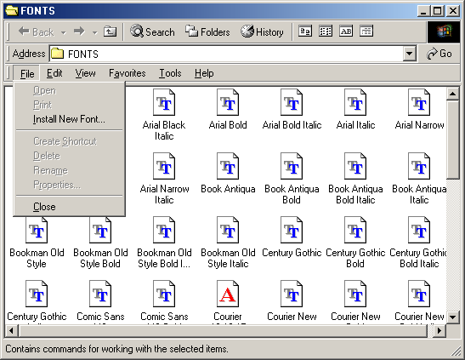

6. Zabi Drive, kuma a duba Kundin (Folder) da kuka sa Bakaken Hausan da kuke son sanyawa kamar haka:

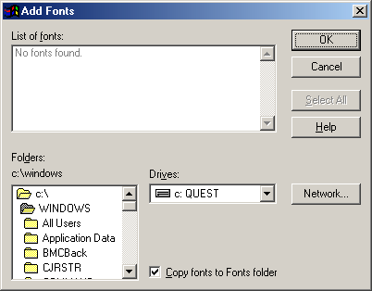

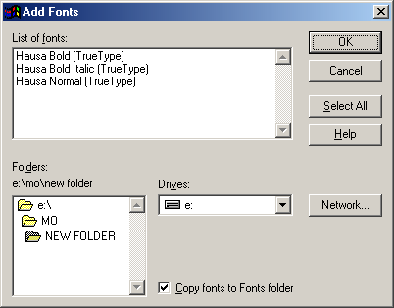

7. Zabi Sellect All daga hannun dama domin sanya Bakaken uku gaba daya

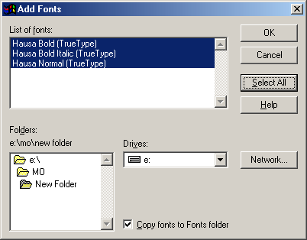

8. Zabi OK ka danna domin sanya Bakaken .

Wannan ita ce hanyar sanya wadannan bakake na Hausa a Komfyutarku

